

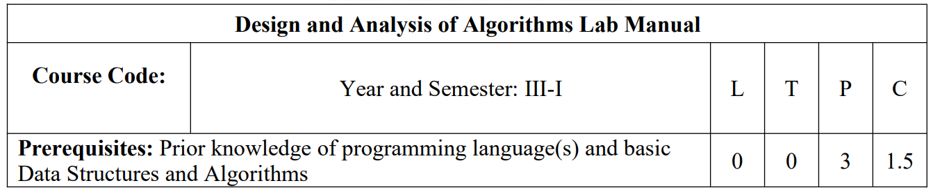

**Course Objectives:**

1. To learn fundamental algorithmic problems.
2. To understand methods of designing and analysing algorithms.
3. To know the various designing paradigms of algorithms for solving real-world problems.

**Course Outcomes:**

At the end of the course, student will be able to:

**CO1**: Identify and apply the suitable algorithm for the given problem.

**CO2**: Design and implement efficient algorithms for a specified application

**Experiment - 1**

Write a program to find the maximum and minimum element from the collection of elements using the divide and conquer technique.

**Procedure:**

A divide-and-conquer algorithm for this problem would proceed as follows:

Let P = (n,a[i],….,a[j]) denote an arbitrary instance of the problem. Here n is the number of elements in the list a[i],…., a[j] and we are interested in finding the maximum and minimum of this list.

Let small(P) be true when n ≤ 2.

If n = 1, the maximum and minimum are a[i].

If n = 2, the problem can be solved by making one comparison.

If the list has more than two elements, P has to be divided into smaller instances.

For example, we might divide P into the two instances

P1 = (n/2,a[1],….,a[n/2]) and P2 = (n - n/2,a[n/2 + 1],….,a[n]).

After having divided P into two smaller subproblems, we can solve them by recursively invoking the same divide and conquer algorithm.

We can combine the Solutions for P1 and P2 to obtain the solution for P as follows.

If MAX(P) and MIN(P) are the maximum and minimum of the elements of P, then MAX(P) is the larger of MAX(P1) and MAX(P2) also MIN(P) is smaller than MIN(P1) and MIN(P2).

MaxMin is a recursive algorithm that finds the maximum and minimum of the set of elements

{a(i), a(i+1),…,a(j)}. The situation of set sizes one (i=j) and two (i=j-1) are handled separately. For sets containing more than two elements, the midpoint is determined, and two new sub-problems are generated. When the maxima and minima of these sub-problems are determined, the two maxima are compared, and the two minima are compared to achieve the solution for the entire set. Suppose we simulate MaxMin on the following nine elements:

Ex: a: [1] [2] [3] [4] [5] [6] [7] [8] [9]

22 13 -5 -8 15 60 17 31 47

A good way of keeping track of recursive calls is to build a tree by adding a node each time a new call is made. On the array a[ ] above, the following tree is produced.

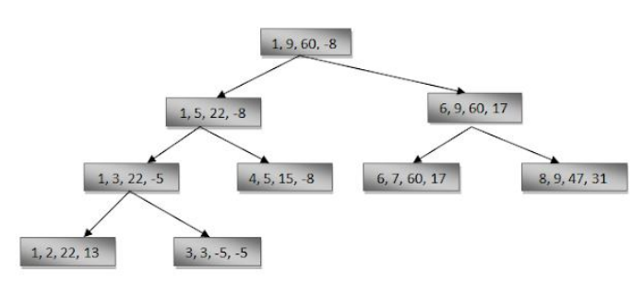

**Algorithm:**

Algorithm MaxMin(i, j, max, min)

// a[1:n] is a global array. Parameters i and j are integers,

// 1≤i≤j≤n. The effect is to set max and min to the largest and

// smallest values in a[i:j].

{

if (i=j) then max := min := a[i]; //Small(P)

else if (i=j-1) then // Another case of Small(P)

{

if (a[i] < a[j]) then max := a[j]; min := a[i];

else max := a[i]; min := a[j];

}

else

{

// if P is not small, divide P into sub-problems.

// Find where to split the set.

mid := ( i + j )/2;

// Solve the sub-problems.

 MaxMin( i, mid, max, min );

MaxMin( mid+1, j, max1, min1 );

// Combine the solutions.

if (max < max1) then max := max1;

if (min > min1) then min := min1;

}

}

**Sample Implementation:**

#include <stdio.h>

int max, min;

int a[100];

void maxmin(int i, int j) {

    int max1, min1, mid;

    if (i == j) {

        max = min = a[i];

    } else {

        if (i == j - 1) {

            if (a[i] < a[j]) {

                max = a[j];

                min = a[i];

            } else {

                max = a[i];

                min = a[j];

            }

        } else {

            mid = (i + j) / 2;

            maxmin(i, mid);

            max1 = max;

            min1 = min;

            maxmin(mid + 1, j);

            if (max < max1) max = max1;

            if (min > min1) min = min1;

        }

    }

}

void main() {

    int i, s;

    printf("\n Enter size of input....");

    scanf("%d", &s);

    printf("Enter the numbers : \n");

    for (i = 1; i <= s; i++) scanf("%d", &a[i]);

    max = -1;

    min = 9999;

    maxmin(1, s);

    printf("maximum element is: %d\n", max);

    printf("minimum element is: %d\n", min);

}

**Output:**

Enter size of input....5

Enter the numbers :

12

56

2

45

67

maximum element is: 67

minimum element is: 2

**Experiment 2**

Write a program to find the optimal profit of a Knapsack using Greedy method.

**Procedure:**

Greedy Method:

The greedy method is the most straight forward design technique, used to determine a feasible solution that may or may not be optimal.

Feasible solution:- Most problems have n inputs and its solution contains a subset of inputs that satisfies a given constraint(condition). Any subset that satisfies the constraint is called feasible solution.

Optimal solution: To find a feasible solution that either maximizes or minimizes a given objective function. A feasible solution that does this is called optimal solution.

The greedy method suggests that an algorithm works in stages, considering one input at a time. At each stage, a decision is made regarding whether a particular input is in an optimal solution.

Knapsack problem

The knapsack problem or rucksack (bag) problem is a problem in combinatorial

optimization: Given a set of items, each with a mass and a value, determine the number of each item to include in a collection so that the total weight is less than or equal to a given limit and the total value is as large as possible.

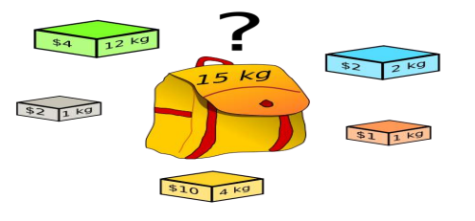

There are two versions of the problems

1. 0/1 knapsack problem

2. Fractional Knapsack problem

a. Bounded Knapsack problem.

b. Unbounded Knapsack problem.

Solutions to knapsack problems

Brute-force approach:-Solve the problem with a straight forward algorithm

Greedy Algorithm:- Keep taking most valuable items until maximum weight is reached or taking the largest value of each item by calculating vi=valuei/Sizei

Fractional knapsack problem is solved using greedy method as follows

1. For each item, compute its value / weight ratio.

2. Arrange all the items in decreasing order of their value / weight ratio.

3. Start putting the items into the knapsack beginning from the item with the highest ratio.

Put as many items as you can into the knapsack.

Example:

Consider the following instance of the knapsack problem: n = 3, m = 20, (p1, p2, p3) = (25, 24, 15) and (w1, w2, w3) = (18, 15, 10).

1. First, we try to fill the knapsack by selecting the objects in some

order:

**x1 x2 x3 wixi pixi**

½ 1/3 ¼ 18 x 1/2 +15 x 1/3 +10 x 1/4 25 x ½ + 24 x 1/3 + 15 x 1/4

= 16.5 = 24.25

2. Select the object with the maximum profit first (p = 25). So, x1 = 1 and profit earned is 25. Now, only 2 units of space is left, select the object with next largest profit (p = 24). So, x2 = 2/15

**x1 x2 x3 wixi pixi**

1 2/15 0 18 x 1 + 15 x 2/15 = 20 25 x 1 + 24 x 2/15 = 28.2

3. Considering the objects in the order of non-decreasing weights wi.

**x1 x2 x3 wixi pixi**

0 2/3 1 15 x 2/3 + 10 x 1 = 20 24 x 2/3 + 15 x 1 = 31

4. Considered the objects in the order of the ratio pi / wi .

**p1/w1 p2/w2 p3/w3**

25/18 24/15 15/10

1.4 1.6 1.5

Sort the objects in order of the non-increasing order of the ratio pi / xi. Select the object with the maximum pi / xi ratio, so, x2 = 1 and profit earned is 24. Now, only 5 units of space is left, select the object with

next largest pi / xi ratio, so x3 = ½ and the profit earned is 7.5.

**x1 x2 x3 wixi pixi**

0 1 1/2 15 x 1 + 10 x 1/2 = 20 24 x 1 + 15 x 1/2 = 31.5

Optimal solution.

**Algorithm:**

If the objects are already been sorted into non-increasing order of p[i] / w[i] then the

algorithm given below obtains solutions corresponding to this strategy.

**Algorithm GreedyKnapsack (m, n)**

// P[1 : n] and w[1 : n] contain the profits and weights respectively of

// Objects ordered so that p[i] / w[i] > p[i + 1] / w[i + 1].

// m is the knapsack size and x[1: n] is the solution vector.

{

for i := 1 to n do x[i] := 0.0

// initialize x U := m;

for i := 1 to n do

{

if (w(i) > U) then break;

x [i] := 1.0; U := U – w[i];

}

if (i < n) then x[i] := U / w[i];

}

**Sample Implementation:**

#include <stdio.h>

void knapsack(int n, float weight[], float profit[], float capacity) {

    float x[20], pr = 0;

    int i, j, u;

    u = capacity;

    for (i = 0; i < n; i++) x[i] = 0.0;

    for (i = 0; i < n; i++) {

        if (weight[i] > u)

            break;

        else {

            x[i] = 1.0;

            pr = pr + profit[i];

            u = u - weight[i];

        }

    }

    if (i < n) x[i] = u / weight[i];

    pr = pr + (x[i] * profit[i]);

    printf("\n Result array x is...");

    for (i = 0; i < n; i++) printf("%f\t", x[i]);

    printf("\n Profit is..... %f", pr);

}

void main() {

    float weight[20], profit[20], capacity;

    int n, i, j;

    float ratio[20], t;

    printf("\n enter the capacityacity of knapsack...");

    scanf("%f", &capacity);

    printf("\n Toal no of objects...");

    scanf("%d", &n);

    printf("\n Enter the weights and profits of each object...");

    for (i = 0; i < n; i++) {

        scanf("%f %f", &weight[i], &profit[i]);

    }

    for (i = 0; i < n; i++) {

        ratio[i] = profit[i] / weight[i];

    }

    for (i = 0; i < n; i++) {

        for (j = i + 1; j < n; j++) {

            if (ratio[i] < ratio[j]) {

                t = ratio[j];

                ratio[j] = ratio[i];

                ratio[i] = t;

                t = weight[j];

                weight[j] = weight[i];

                weight[i] = t;

                t = profit[j];

                profit[j] = profit[i];

                profit[i] = t;

            }

        }

    }

    knapsack(n, weight, profit, capacity);

}

**Output:**

enter the capacityacity of knapsack...20

Toal no of objects...3

Enter the weights and profits of each object...18 25

15 24

10 15

Result array x is...1.000000 0.500000 0.000000

Profit is..... 31.500000

**Experiment 3:**

Write a program for Optimal Merge Patterns problem using Greedy Method.

* Given ‘n’ sorted files, there are many ways to pair wise merge them into a single sorted file. As, different pairings require different amounts of computing time, we want to determine an optimal (i.e., one requiring the fewest comparisons) way to pair wise merge ‘n’ sorted files together.
* This type of merging is called as 2-way merge patterns.
* To merge an n-record file and an m-record file requires possibly n + m record moves, the obvious choice is, at each step merge the two smallest files together.
* To merge an n-record file and an m-record file requires possibly n + m record moves, the obvious choice is, at each step merge the two smallest files together.

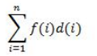

Where, f (i) represents the number of records in each file and d (i) represents the depth.

**Algorithm:**

struct treenode

{

treenode *lchild;

treenode *rchild;

};

Algorithm TREE (n)

// list is a global of n single node binary trees

{

for i := 1 to n – 1 do

{

pt new treenode

(pt ->lchild)= least (list);

// merge two trees with smallest lengths

(pt->rchild) least (list);

(pt-> weight)=((pt-> lchild)->weight)+((pt->rchild)->weight);

insert (list,pt);

}

return least (list);

}

* An optimal merge pattern corresponds to a binary merge tree with minimum weighted external path length
* The function tree algorithm uses the greedy rule to get a two- way merge tree for n files. The algorithm contains an input list of n trees.
* There are three field child, rchild, and weight in each node of the tree. Initially, each tree in a list contains just one node.
* This external node has lchild and rchild field zero whereas weight is the length of one of the n files to be merged.
* For any tree in the list with root node t, t = it represents the weight that gives the length of the merged file.
* There are two functions least (list) and insert (list, t) in a function tree.
* Least (list) obtains a tree in lists whose root has the least weight and return a pointer to this tree.
* This tree is deleted from the list.
* Function insert (list, t) inserts the tree with root t into the list.
* The main for loop in this algorithm is executed in n-1 times.
* If the list is kept in increasing order according to the weight value in the roots, then least (list) needs only O(1) time and insert (list, t) can be performed in O(n) time. Hence, the total time taken is O (n2).
* If the list is represented as a minheap in which the root value is less than or equal to the values of its children, then least (list) and insert (list, t) can be done in O (log n) time. In this condition, the computing time for the tree is O (n log n).

Example:

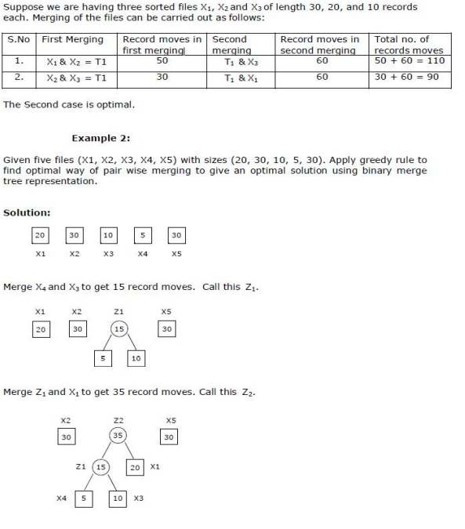

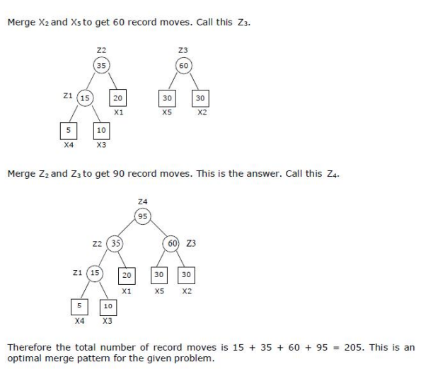

**Sample Implementation:**

// programme to generate optimal merge patterns

#include <stdio.h>

#include <stdlib.h>

int ops;

struct node {

    int weight;

    struct node *left, *right;

};

// min heap for storing nodes

struct heapn {

    int size;

    int capacity;

    struct node** array;

};

// function to crete new node

struct node* newnode(int weight) {

    struct node* temp = (struct node*)malloc(sizeof(struct node));

    temp->left = temp->right = NULL;

    temp->weight = weight;

    return temp;

}

// function to create a minimum heap

struct heapn* createminheap(int capacity) {

    struct heapn* minheap = (struct heapn*)malloc(sizeof(struct heapn));

    minheap->size = 0;

    minheap->capacity = capacity;

    minheap->array =

        (struct node**)malloc(minheap->capacity * sizeof(struct node*));

    return minheap;

}

void swapnode(struct node** n1, struct node** n2) {

    struct node* t = *n1;

    *n1 = *n2;

    *n2 = t;

}

// function to heapify

void heapify(struct heapn* minheap, int idx) {

    int min = idx;

    int left = 2 * idx + 1;

    int right = 2 * idx + 2;

    if (left < minheap->size &&

        minheap->array[left]->weight < minheap->array[min]->weight)

        min = left;

    if (right < minheap->size &&

        minheap->array[right]->weight < minheap->array[min]->weight)

        min = right;

    if (min != idx) {

        swapnode(&minheap->array[min], &minheap->array[idx]);

        heapify(minheap, min);

    }

}

// extract minimum node

struct node* extractmin(struct heapn* minheap) {

    struct node* temp = minheap->array[0];

    minheap->array[0] = minheap->array[minheap->size - 1];

    --minheap->size;

    heapify(minheap, 0);

    return temp;

}

// insert new node to Min Heap

void insert(struct heapn* minheap, struct node* minh) {

    ++minheap->size;

    int i = minheap->size - 1;

    while (i && minh->weight < minheap->array[(i - 1) / 2]->weight) {

        minheap->array[i] = minheap->array[(i - 1) / 2];

        i = (i - 1) / 2;

    }

    minheap->array[i] = minh;

}

// function to initialize heap

void buildheap(struct heapn* minheap) {

    int n = minheap->size - 1;

    int i;

    for (i = (n - 1) / 2; i >= 0; --i) heapify(minheap, i);

}

// Creates a min heap of capacity

struct heapn* create(int d[], int size) {

    struct heapn* minheap = createminheap(size);

    for (int i = 0; i < size; ++i) minheap->array[i] = newnode(d[i]);

    minheap->size = size;

    buildheap(minheap);

    return minheap;

}

// The main function that builds Huffman tree

struct node* optt(int d[], int size) {

    struct node *left, *right, *top;

    struct heapn* minheap = create(d, size);

    int i = 0, t, tot = 0;

    printf("\n");

    while (!(minheap->size == 1)) {

        left = extractmin(minheap);

        right = extractmin(minheap);

        t = left->weight + right->weight;

        tot = tot + t;

        printf("\n merge %d and %d cost is =%d", left->weight, right->weight,

               t);

        top = newnode(left->weight + right->weight);

        top->left = left;

        top->right = right;

        insert(minheap, top);

    }

    printf("\n total merge cost is...:%d", tot);

    return extractmin(minheap);

}

void main() {

    int fr[10], n, i;

    printf("\n Enter the no of files:");

    scanf("%d", &n);

    printf("enter the records of %d file", n);

    for (i = 0; i < n; i++) scanf("\n %d", &fr[i]);

    struct node* root = optt(fr, n);

}

**Output:**

Enter the no of files:4

enter the records of 4 file20

10

15

5

merge 5 and 10 cost is =15

merge 15 and 15 cost is =30

merge 20 and 30 cost is =50

total merge cost is...:95

**Experiment 4:**

Write a program for Single Source Shortest Path for General Weights using

Dynamic Programming.

* Bellman Ford algorithm helps to find the shortest path from a vertex to all other vertices of a weighted graph.
* Bellman Ford algorithm works by overestimating the length of the path from the starting vertex to all other vertices. Then it iteratively relaxes those estimates by finding new paths that are shorter than the previously overestimated paths.

**Procedure:**

* Maintain the path distance of every vertex. We can store that in an array of size v, where v is the number of vertices.
* We also want to be able to get the shortest path, not only know the length of the shortest path. For this, we map each vertex to the vertex that last updated its pathlength.
* Once the algorithm is over, we can backtrack from the destination vertex to the source vertex to find the path.

**Algorithm:**

Algorithm bellmanFord(G,S)

for each vertex V in G

distance[V] <- infinite

previous[V] <- NULL

distance[S] <- 0

for each vertex V in G

for each edge (U,V) in G

tempDistance <- distance[U] + edge_weight(U, V)

if tempDistance < distance[V]

distance[V] <- tempDistance

previous[V] <- U

for each edge (U,V) in G

If distance[U] + edge_weight(U, V) < distance[V}

Error: Negative Cycle Exists

return distance[], previous[]

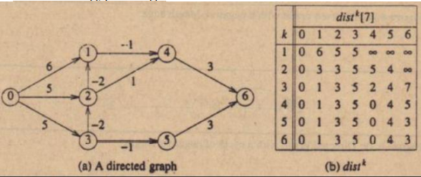

**Sample Implementation:**

#include <stdio.h>

#include <stdlib.h>

#define INF 9999

struct edge {

    int u;

    int v;

    int w;

};

struct graph {

    int vertices;

    int edges;

    struct edge *edge;

};

void bellmanford(struct graph *g, int source);

void display(int arr[], int size);

int main(void) {

    int v, e, i;

    // create graph

    struct graph *g = (struct graph *)malloc(sizeof(struct graph));

    printf("\n enter the total vertices and edges:");

    scanf("%d%d", &v, &e);

    g->vertices = v;

    g->edges = e;

    g->edge = (struct edge *)malloc(g->edges * sizeof(struct edge));

    printf("\n enter edge u,v and weight w..:");

    for (i = 0; i < e; i++) {

        scanf("%d%d%d", &g->edge[i].u, &g->edge[i].v, &g->edge[i].w);

    }

    bellmanford(g, 0);

    return 0;

}

void bellmanford(struct graph *g, int source) {

    int i, j, u, v, w;

    int ve = g->vertices;  // total no of vertices

    int ee = g->edges;     // total no of edges

    int d[ve];

    int p[ve];

    // predecessor array

    // initialize distance and predessor array

    for (i = 0; i < ve; i++) {

        d[i] = INF;

        p[i] = 0;

    }

    d[source] = 0;

    for (i = 1; i <= ve - 1; i++)  // relax edges

    {

        for (j = 0; j < ee; j++) {

            u = g->edge[j].u;

            v = g->edge[j].v;

            w = g->edge[j].w;

            if (d[u] != INF && d[v] > d[u] + w) {

                d[v] = d[u] + w;

                p[v] = u;

            }

        }

    }

    for (i = 0; i < ee; i++)  // check for negative cycle

    {

        u = g->edge[i].u;

        v = g->edge[i].v;

        w = g->edge[i].w;

        if (d[u] != INF && d[v] > d[u] + w) {

            printf("\n Negative Cycle...:");

            return;

        }

    }

    printf("distance array: ");

    display(d, ve);

    printf("predecessor array: ");

    display(p, ve);

}

void display(int arr[], int size) {

    int i;

    for (i = 0; i < size; i++) {

        printf("\n %d", arr[i]);

    }

    printf("\n");

}

**Output:**

enter the total vertices and edges:7

10

enter edge u,v and weight w..:0 1 6

0 2 5

0 3 5

1 4 -1

2 1 -2

3 2 -2

2 4 1

3 5 -1

4 6 3

5 6 3

distance array:

0

1

3

5

0

4

3

predecessor array:

0

2

3

0

1

3

4

**Experiment 5:**

Write a program to find all pair shortest path from any node to any other node within a graph.

* Floyd-Warshall Algorithm is an algorithm for finding the shortest path between all the pairs of vertices in a weighted graph.
* This algorithm works for both the directed and undirected weighted graphs.
* It does not work for the graphs with negative cycles (where the sum of the edges in a cycle is negative).
* This algorithm follows the dynamic programming approach to find the shortest paths.

**Algorithm:**

Algorithm Floydwarshal()

{

//Initialize the cost matrix

for i := 1 to N

for j := 1 to N

if there is an edge from i to j

dist[0][i][j]:= the length of the edge from i to j

else

dist[0][i][j] := INFINITY

for k:= 1 to N

for I:= 1 to N

for j:= 1 to N

dist[k][i][j]:= min(dist[k-1][i][j], dist[k-1][i][k] + dist[k-1][k][j])

}

* Initialize the cost matrix same as the input graph matrix.
* update the solution matrix by considering all vertices as an intermediate vertex.
* consider vertex k as an intermediate vertex.
* For every pair (i, j) of the source and destination vertices respectively.

1. k is not an intermediate vertex in shortest path from i to j. no change in the value of dist[i][j].
2. k is an intermediate vertex in shortest path from i to j.

Update the value of dist[i][j] as

dist[k][i][j]:= min(dist[k-1][i][j], dist[k-1][i][k] + dist[k-1][k][j])

**Sample implementation:**

#include <conio.h>

#include <stdio.h>

int min(int, int);

void floyds(int c[10][10], int n) {

    int i, j, k;

    for (k = 1; k <= n; k++)

        for (i = 1; i <= n; i++)

            for (j = 1; j <= n; j++)

                if (i == j)

                    c[i][j] = 0;

                else

                    c[i][j] = min(c[i][j], c[i][k] + c[k][j]);

}

int min(int a, int b) {

    if (a < b)

        return a;

    else

        return b;

}

void main() {

    int c[10][10], w, n, e, u, v, i, j;

    printf("\n enter the number of vertices:");

    scanf("%d", &n);

    printf("\n enter the number of edges:\n");

    scanf("%d", &e);

    for (i = 1; i <= n; i++) {

        for (j = 1; j <= n; j++) c[i][j] = 999;

    }

    printf("\n enter the edge,weight for %d edges \n", e);

    for (i = 1; i <= e; i++) {

        scanf("%d%d%d", &u, &v, &w);

        c[u][v] = w;

    }

    printf("\n Matrix of input data:\n");

    for (i = 1; i <= n; i++) {

        for (j = 1; j <= n; j++) printf("%d \t", c[i][j]);

        printf("\n");

    }

    floyds(c, n);

    printf("\n cost matrix:\n");

    for (i = 1; i <= n; i++) {

        for (j = 1; j <= n; j++) printf("%d \t", c[i][j]);

        printf("\n");

    }

    printf("\n shortest paths are:\n");

    for (i = 1; i <= n; i++)

        for (j = 1; j <= n; j++) {

            if (i != j)

                printf("\nshortest path from %d to %d is %d", i, j, c[i][j]);

        }

    getch();

}

**Output:**

PS C:\Users\vamsivallepu\DAA> cd "c:\Users\vamsivallepu\DAA\" ; if ($?) { gcc Floydwarshal.c -o Floydwarshal } ; if ($?) { .\Floydwarshal }

enter the number of vertices:4

enter the number of edges:

6

enter the edge,weight for 6 edges

1 2 3

2 1 2

1 4 5

2 4 4

3 2 1

4 3 2

Matrix of input data:

999 3 999 5

2 999 999 4

999 1 999 999

999 999 2 999

cost matrix:

0 3 7 5

2 0 6 4

3 1 0 5

5 3 2 0

shortest paths are:

shortest path from 1 to 2 is 3

shortest path from 1 to 3 is 7

shortest path from 1 to 4 is 5

shortest path from 2 to 1 is 2

shortest path from 2 to 3 is 6

shortest path from 2 to 4 is 4

shortest path from 3 to 1 is 3

shortest path from 3 to 2 is 1

shortest path from 3 to 4 is 5

shortest path from 4 to 1 is 5

shortest path from 4 to 2 is 3

shortest path from 4 to 3 is 2

**Experiment 6:**

Write a program to find the non-attacking positions of Queens in a given chess board using backtracking.

Problem:

Place N queens on an N x N chessboard so that no two queens attack each other. that is no two queens share the same row, column, or diagonal.

One possible solution when n=8

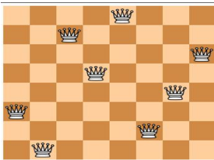

**Algorithm:**

Algorithm place will check whether queen can be placed at kth row and ith column

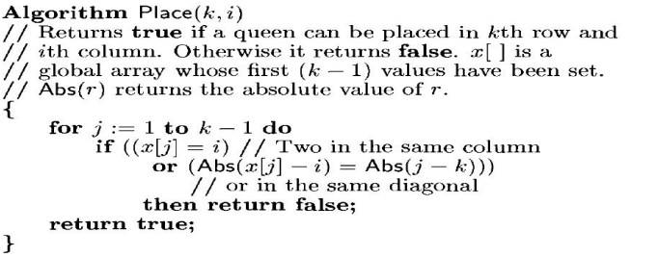

Algorithm Nqueens place queens in safe positions using backtracking.

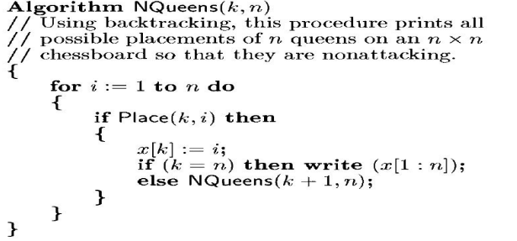

**Sample Implementation:**

#include <conio.h>

#include <math.h>

#include <stdio.h>

int x[30], count = 0;

int place(int pos) {

    int i;

    for (i = 1; i < pos; i++) {

        if ((x[i] == x[pos]) || ((abs(x[i] - x[pos]) == abs(i - pos))))

            return 0;

    }

    return 1;

}

void printboard(int n) {

    int i, j;

    count++;

    printf("\n\nsolution%d:\n", count);

    for (i = 1; i <= n; i++) {

        for (j = 1; j <= n; j++) {

            if (x[i] == j)

                printf("Q%d\t", i);

            else

                printf("*\t");

        }

        printf("\n");

    }

}

void queen(int n) {

    int k = 1;

    x[k] = 0;

    while (k != 0) {

        x[k] = x[k] + 1;

        while ((x[k] <= n) && !place(k)) x[k]++;

        if (x[k] <= n) {

            if (k == n)

                printboard(n);

            else {

                k++;

                x[k] = 0;

            }

        } else

            k--;

    }

}

void main() {

    int i, n;

    printf("enter the number of queens..:");

    scanf("%d", &n);

    queen(n);

    printf("\npossible solutions..: %d", count);

    getch();

}

**Output:**

enter the number of queens..:4

solution1:

* Q1 * *

* * * Q2

Q3 * * *

* * Q4 *

solution2:

* * Q1 *

Q2 * * *

* * * Q3

* Q4 * *

possible solutions..: 2

**Experiment 7:**

Find a subset of a given set S = {Sl, S2, ....., Sn} of n positive integers, whose sum is

equal to a given positive integer d.

For example, if S= {1, 2, 5, 6, 8} and d = 9 there

are two solutions {1, 2, 6} and {1, 8}. A suitable message is to be displayed if the

given problem instance doesn't have a solution.

Problem:

* Given positive numbers wi, 1 ≤ i ≤ n, and m, this problem requires finding all subsets of wi whose sums are m.
* All solutions are k-tuples, 1 ≤ k ≤ n. Explicit constraints:

xi Є{j | j is an integer and 1 ≤j ≤n}.

Implicit constraints:

* No two xi can be the same.
* The sum of the corresponding wi be m.

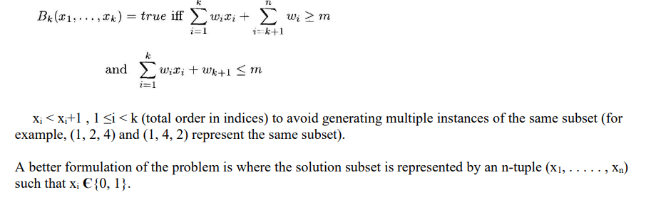

**Algorithm:**

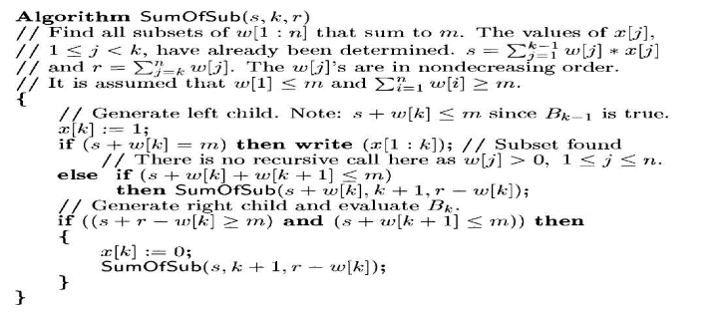

**Procedure:**

n = 4, w = (11, 13, 24, 7) and m = 31, the desired subsets are (11,13, 7) and (24, 7).

* Solution to the problem constructed by considering the each element in the set.
* Decision is made either to select or reject the element.
* If the element is selected it is added to the partial sum.
* If it is rejected then it is not added to the partial solution.
* Constraint is verified after selecting an element if constraint violated algorithm backtrack to consider the next alternative.
* If constraint satisfied algorithm proceeds to make decision on next element.

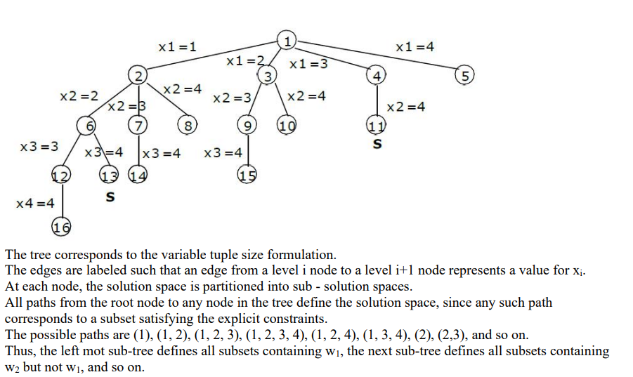

**Sample Implementation:**

#include <conio.h>

#include <stdio.h>

int s[10], d, n, set[10], count = 0;

void display(int);

int flag = 0;

void main() {

    int subset(int, int);

    int i;

    printf("Enter the number of elements in set\n");

    scanf("%d", &n);

    printf("Enter the set values\n");

    for (i = 0; i < n; ++i) scanf("%d", &s[i]);

    printf("Enter the sum\n");

    scanf("%d", &d);

    printf("The progrm output is\n");

    subset(0, 0);

    if (flag == 0) printf("there is no solution");

    getch();

}

int subset(int sum, int i) {

    if (sum == d) {

        flag = 1;

        display(count);

        return 0;

    }

    if (sum > d || i >= n)

        return 0;

    else {

        set[count] = s[i];

        count++;

        subset(sum + s[i], i + 1);

        count--;

        subset(sum, i + 1);

    }

}

void display(int count) {

    int i;

    printf("{");

    for (i = 0; i < count; i++) printf("%d ", set[i]);

    printf("}");

}

**Output:**

Enter the number of elements in set

5

Enter the set values

1 3 4 5 6

Enter the sum

9

The progrm output is

{1 3 5 }{3 6 }{4 5 }

**Experiment 8:**

Write a program to color the nodes in a given graph such that no two adjacent can have the same color using backtracking.

**Graph coloring problem:**

* Let G be a graph and m be a given positive integer.
* Find whether the nodes of G can be colored in such a way that no two adjacent nodes have the same color, yet only m colors are used.
* This is termed the m-colorabiltiy decision problem.
* The m-colorability optimization problem asks for the smallest integer m for which the graph G can be colored.
* The function m-coloring will begin by first assigning the graph to its adjacency matrix, setting the array x [] to zero.
* The colors are represented by the integers 1, 2, . . . , m and the solutions are given by the n-tuple (x1, x2, . . ., xn), where xi is the color of node i.
* A recursive backtracking algorithm for graph coloring is carried out by invoking the statement mcoloring(1);

**Algorithm:**

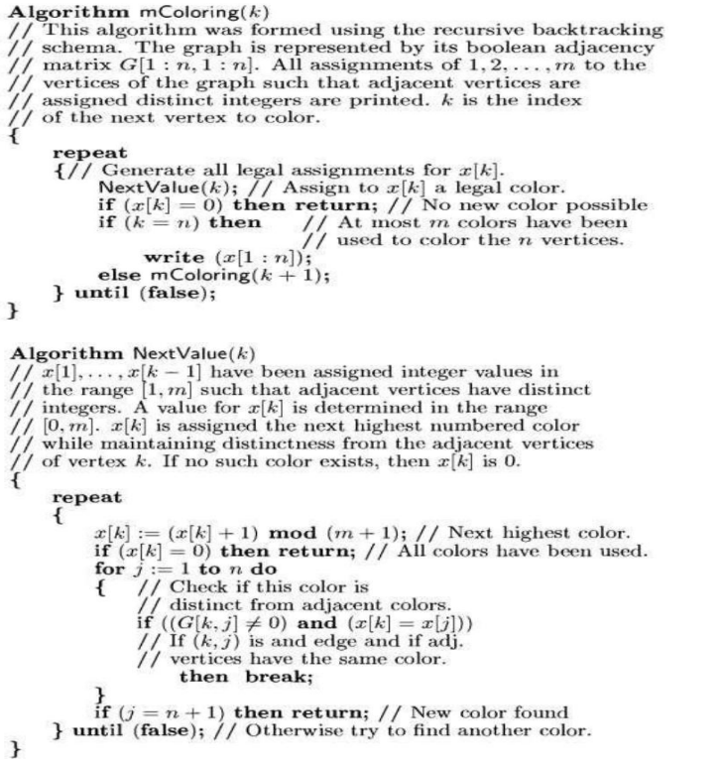

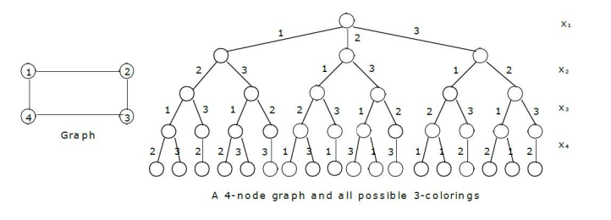

**Sample Implementation:**

#include <conio.h>

#include <stdio.h>

int m, n;

int c = 0;

int sol = 0;

int g[10][10];

int x[10];

void nextvalue(int k);

void graphcoloring(int k);

void main() {

    int i, j, t;

    printf("\n enter the number of vertices in a graph: ");

    scanf("%d", &n);

    printf("\n enter graph edges\n");

    for (i = 1; i <= n; i++) {

        for (j = 1; j <= n; j++) {

            scanf("%d", &g[i][j]);

        }

    }

    printf("\n All possible solutions are\n");

    for (m = 1; m <= n; m++) {

        if (c == 1) {

            break;

        }

        graphcoloring(1);

    }

    printf("\n chromatic number is %d", m - 1);

    printf("\n total number of solutions is %d", sol);

    getch();

}

void graphcoloring(int k) {

    int i;

    while (1) {

        nextvalue(k);

        if (x[k] == 0) {

            return;

        }

        if (k == n) {

            c = 1;

            for (i = 1; i <= n; i++) {

                printf("%d ", x[i]);

            }

            sol++;

            printf("\n");

        } else

            graphcoloring(k + 1);

    }

}

void nextvalue(int k) {

    int j;

    while (1) {

        x[k] = (x[k] + 1) % (m + 1);

        if (x[k] == 0) {

            return;

        }

        for (j = 1; j <= n; j++) {

            if (g[k][j] == 1 && x[k] == x[j]) break;

        }

        if (j == (n + 1)) {

            return;

        }

    }

}

**Output:**

enter the number of vertices in a graph: 4

enter graph edges

0 1 1 1

1 0 1 1

1 1 0 1

1 0 1 0

All possible solutions are

1 2 3 2

1 3 2 3

2 1 3 1

2 3 1 3

3 1 2 1

3 2 1 2

chromatic number is 3

total number of solutions is 6

**Experiment 9:**

Design and implement to find all Hamiltonian Cycles in a connected undirected Graph G of n vertices

using Backtracking principle.

Problem:

* Given graph G with n vertices and E edges. Find all possible Hamiltonian cycles in a graph.
* The Hamiltonian cycle is the cycle that traverses all the vertices of the given graph G exactly once and then ends at the starting vertex.
* The input can be the directed or undirected graph.
* Graph G is represented as boolean valued adjacency matrix

Where G[i,j]= 1 if there exist an edge between i,j = 0 otherwise

Backtracking Solution:

* Problem involves checking if the Hamiltonian cycle is present in a graph G or not.
* Following bounding functions are to be considered while generating possible Hamiltonian cycles

1. The kth visiting vertex in the path must be adjacent to the (k-1)th visiting vertex in any path (G[x[k-1],x[k]]==1).

2. The starting vertex and the nth vertex should be adjacent (G[x[n],x[1])==1.

3. Each vertex should be visited only once.

**Algorithm:**

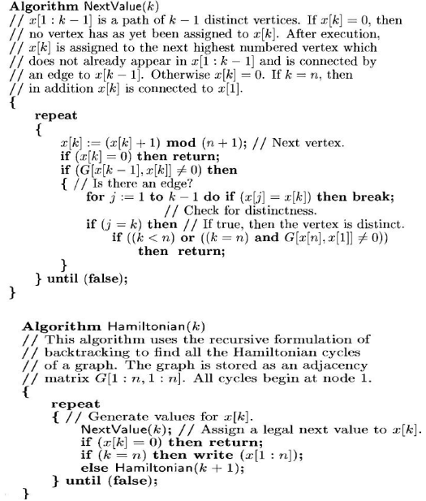

* The graph is stored as an adjacency matrix g[1: n, 1: n].
* In the next value k, x [1: k-1] is a path with k-1 distinct vertices.
* if x[k] == 0 then no vertex has to be yet been assign to x[k].
* After execution x[k] is assigned to the next highest numbered vertex which does not already appear in the path x [1: k-1] and is connected by an edge to x [k – 1] otherwise x[k] == 0.
* If k == n, (here n is the number of vertices) then in addition x[n] is connected to x [1].

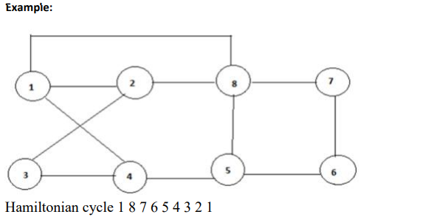

**Sample Implementation:**

#include <stdio.h>

void displaycycl();

void nextvalue(int k);

int g[10][10], n, x[10], c = 0;

// hamilton cycle algorithm

void hamiltonian(int k) {

    while (1) {

        nextvalue(k);

        if (x[k] == 0) {

            return;

        }

        if (k == n) {

            c = c + 1;

            displaycycl();

        } else {

            hamiltonian(k + 1);

        }

    }

}

// nextvalue algorithm to determine kth visiting vertex

void nextvalue(int k) {

    int j;

    while (1) {

        x[k] = (x[k] + 1) % (n + 1);

        if (x[k] == 0) {

            return;

        }

        if (g[x[k - 1]][x[k]] != 0) {

            for (j = 1; j <= k - 1; j++) {

                if (x[j] == x[k]) {

                    break;

                }

            }

            if (j == k) {

                if ((k < n) || ((k == n) && (g[x[n]][x[1]] != 0))) {

                    return;

                }

            }

        }

    }

}

// function to display solutions

void displaycycl() {

    int i;

    for (i = 1; i <= n; i++) printf("%d ", x[i]);

    printf("%d ", x[1]);

    printf("\n");

}

// main function

int main() {

    int i, j;

    printf("\n enter the no of vertices...");

    scanf("%d", &n);

    printf("\n enter the graph info...");

    for (i = 1; i <= n; i++) {

        for (j = 1; j <= n; j++) {

            scanf("%d", &g[i][j]);

        }

    }

    for (i = 1; i <= n; i++) x[i] = 0;

    x[1] = 1;

    printf("\n Hamiltonian cycles possible are....\n");

    hamiltonian(2);

    printf("total %d solutions", c);

    if (c == 0) {

        printf("\n solutions not possible");

    }

    return 0;

}

**Output:**

enter the no of vertices...4

enter the graph info...0 1 1 1

1 0 1 1

1 1 0 1

1 1 1 0

Hamiltonian cycles possible are....

1 2 3 4 1

1 2 4 3 1

1 3 2 4 1

1 3 4 2 1

1 4 2 3 1

1 4 3 2 1

total 6 solutions